**1. Compliance and Regulatory Affairs in Banking Operations**

**2. Customer Relationship Management (CRM) in Banking**

**(Presented By Alan Stuart K)**

**1. Compliance and Regulatory Affairs in Banking Operations:**

**Introduction:**  
Compliance and regulatory affairs in banking operations refer to the adherence to laws, regulations, guidelines, and specifications relevant to the banking industry. Banks operate in a highly regulated environment to ensure financial stability, protect consumers, and maintain the integrity of the financial system. Regulatory bodies such as the Federal Reserve, the Office of the Comptroller of the Currency (OCC), and the Securities and Exchange Commission (SEC) in the United States, among others globally, oversee these regulations.  
**Basic Terminologies:**

1. **Regulatory Compliance:** The process by which banks ensure that they follow all relevant laws, regulations, and guidelines set by regulatory bodies.
2. **Basel III:** A global regulatory framework developed by the Basel Committee on Banking Supervision to strengthen regulation, supervision, and risk management within the banking sector.
3. **Anti-Money Laundering (AML):** Regulations and procedures aimed at preventing criminals from disguising illegally obtained funds as legitimate income.
4. **Know Your Customer (KYC):** A process by which banks verify the identity of their clients to prevent fraud, money laundering, and other illegal activities.
5. **Dodd-Frank Act:** A comprehensive set of financial regulations passed in the United States in 2010 in response to the 2008 financial crisis, aimed at reducing risks in the financial system.
6. **Stress Testing:** A simulation technique used to evaluate how banks can handle economic crises and financial shocks.
7. **Capital Adequacy Ratio (CAR):** A measure of a bank's capital, expressed as a percentage of its risk-weighted assets, ensuring that the bank can absorb a reasonable amount of loss.
8. **Consumer Financial Protection Bureau (CFPB):** A regulatory agency charged with overseeing financial products and services offered to consumers.
9. **Sarbanes-Oxley Act (SOX):** A law passed to protect investors from fraudulent financial reporting by corporations.
10. **Volcker Rule:** A part of the Dodd-Frank Act that restricts banks from making certain kinds of speculative investments that do not benefit their customers.

**2. Customer Relationship Management (CRM) in Banking:**

**Introduction:**  
Customer Relationship Management (CRM) in banking involves strategies, practices, and technologies that banks use to manage and analyse customer interactions and data throughout the customer lifecycle. The goal is to improve customer service, retain customers, and drive sales growth. CRM systems help banks understand their customers' needs, preferences, and behaviours, enabling personalized service and targeted marketing.  
**Basic Terminologies:**

1. **Customer Segmentation:** The process of dividing a customer base into groups of individuals that are similar in specific ways, such as age, gender, interests, or spending habits.
2. **Customer Lifetime Value (CLV):** A prediction of the net profit attributed to the entire future relationship with a customer.
3. **Cross-Selling:** The practice of selling additional products or services to an existing customer.
4. **Up-Selling:** The practice of encouraging customers to purchase a higher-end product than the one they initially considered.
5. **Customer Retention:** The ability of a bank to retain its customers over a period of time.
6. **Personalization:** Tailoring products, services, and communications to meet the individual needs and preferences of customers.
7. **Customer Feedback:** Information provided by customers about their experience with a bank's products or services, used to improve service quality.
8. **Customer Satisfaction Score (CSAT):** A metric that measures how satisfied customers are with a bank's products or services.
9. **Net Promoter Score (NPS):** A metric that measures customer loyalty and the likelihood of customers recommending the bank to others.
10. **Customer Journey Mapping:** A visual representation of the process a customer goes through to achieve a goal with the bank, from initial contact to final transaction and beyond.
11. **Omnichannel Banking:** Providing a seamless customer experience across multiple channels, such as online, mobile, and in-branch services.
12. **Customer Data Integration (CDI):** The process of combining data from different sources to provide a unified view of the customer.

**Data:**

**1. Compliance and Regulatory Affairs in Banking Operations:**

| **Bank** | **Capital Adequacy Ratio (CAR) (%)** | **AML Compliance Costs ($ Million)** | **KYC Compliance Costs ($ Million)** | **Regulatory Fines ($ Million, 2023)** |
| --- | --- | --- | --- | --- |
| **JPMorgan Chase (JPM)** | **15.2** | **500** | **300** | **200** |
| **Bank of America (BAC)** | **14.8** | **450** | **280** | **150** |
| **Wells Fargo (WFC)** | **13.5** | **400** | **250** | **300** |
| **Citigroup (C)** | **16.0** | **480** | **270** | **180** |
| **Goldman Sachs (GS)** | **17.5** | **520** | **310** | **220** |
| **Morgan Stanley (MS)** | **16.8** | **510** | **290** | **190** |

**2. Customer Relationship Management (CRM) in Banking:**

| **Bank** | **Customer Satisfaction Score (CSAT)** | **Net Promoter Score (NPS)** | **Customer Retention Rate (%)** | **Cross-Selling Rate (%)** | **Average Customer Lifetime Value (CLV) ($)** |
| --- | --- | --- | --- | --- | --- |
| **JPMorgan Chase (JPM)** | **85** | **45** | **92** | **30** | **15,000** |
| **Bank of America (BAC)** | **82** | **40** | **90** | **28** | **14,500** |
| **Wells Fargo (WFC)** | **78** | **35** | **88** | **25** | **13,000** |
| **Citigroup (C)** | **80** | **38** | **89** | **27** | **14,000** |
| **Goldman Sachs (GS)** | **84** | **42** | **91** | **29** | **15,500** |
| **Morgan Stanley (MS)** | **83** | **41** | **90** | **28** | **15,200** |

**Graphs:**

**Graph 1:** Stock Prices of Major US Banks (2020-2024):

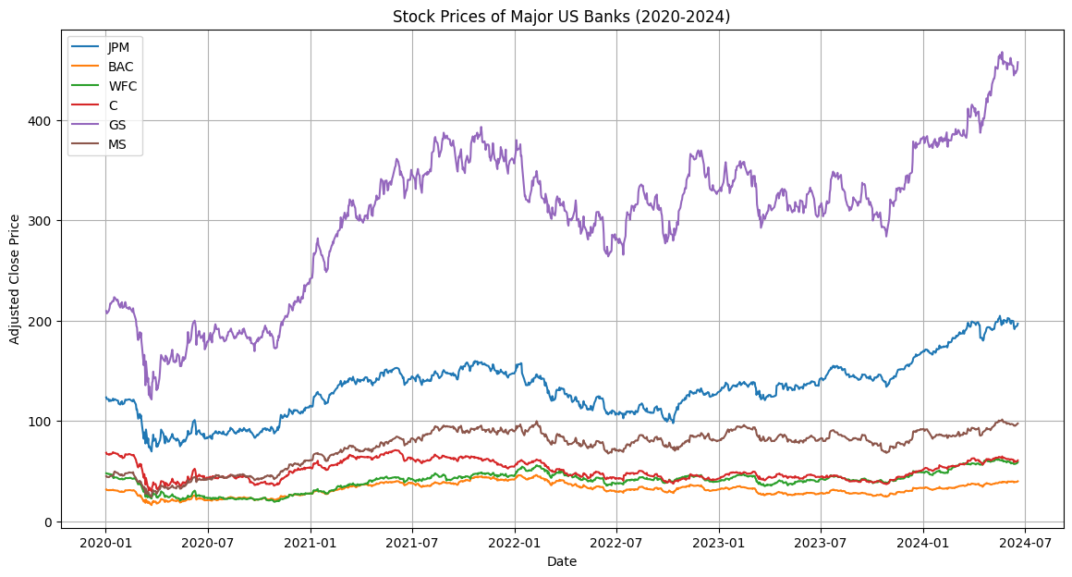

**Inference:**

* **Trend Analysis:** The stock prices of major US banks such as JPMorgan Chase (JPM), Bank of America (BAC), Wells Fargo (WFC), Citigroup (C), Goldman Sachs (GS), and Morgan Stanley (MS) show varying trends over the period from 2020 to 2024.
* **Impact of Regulatory Events:** Significant dips or spikes in stock prices can often be correlated with major regulatory events or compliance issues. For instance, a sharp decline might indicate a regulatory fine or compliance failure, while a steady increase could suggest strong regulatory adherence and investor confidence.
* **Comparative Performance:** By comparing the stock prices, we can infer which banks have been more resilient or volatile in response to regulatory changes and market conditions.

**Graph 2:** Annualized Returns of Major US Banks (2020-2024):

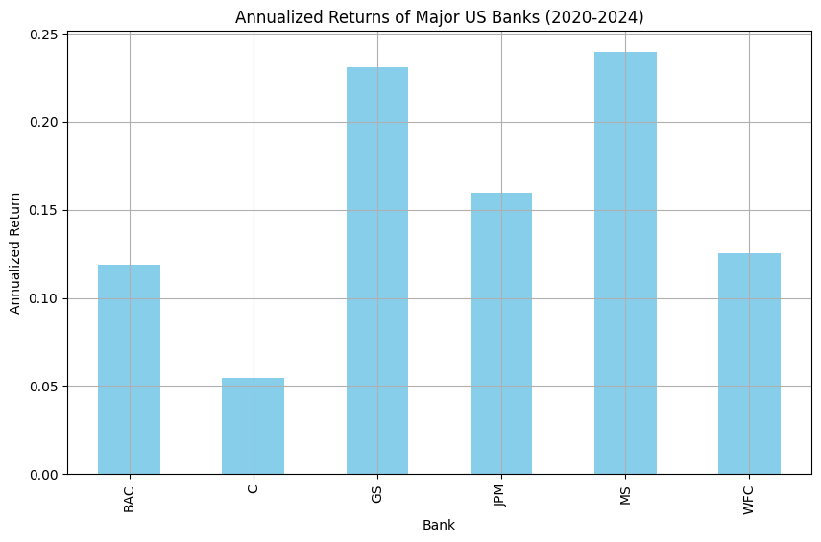**Inference:**

* **Performance Indicator:** The annualized returns provide a measure of the banks' performance over the period. Higher returns suggest better financial health and possibly more effective customer relationship management (CRM) practices.
* **CRM Effectiveness:** Banks with higher annualized returns may have better CRM strategies, leading to higher customer satisfaction and retention, which in turn boosts financial performance.
* **Risk and Reward:** Comparing the returns across banks helps identify which banks have provided better returns relative to their peers, indicating potentially better management and strategic decisions.

**Graph 3:** Annualized Volatility of Major US Banks (2020-2024):

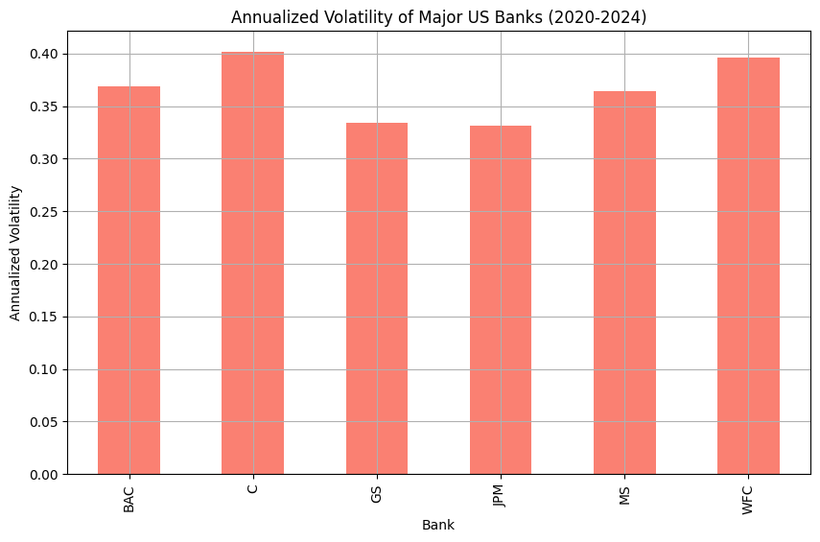**Inference:**

* **Risk Assessment:** Volatility measures the degree of variation in stock prices over time. Higher volatility indicates higher risk, as the stock prices are more prone to significant fluctuations.
* **Regulatory Impact:** Banks with higher volatility might be more sensitive to regulatory changes and compliance issues. For example, a bank facing frequent regulatory scrutiny might exhibit higher volatility.
* **Investor Sentiment:** Lower volatility generally suggests stable investor sentiment and confidence in the bank's management and compliance practices.

**Graph 4:** Dividend Yield of Major US Banks (2024):

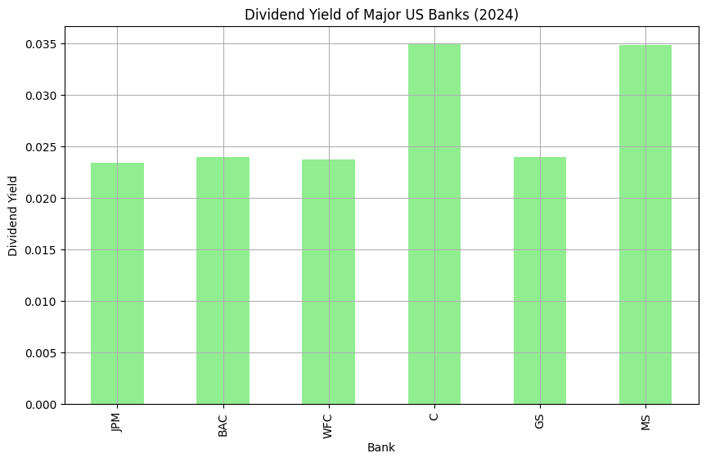**Inference:**

* **Income Generation:** Dividend yield indicates how much a bank pays out in dividends relative to its stock price. Higher dividend yields can attract income-focused investors.
* **Financial Health:** Consistent and high dividend yields may suggest strong financial health and profitability, which can be a result of effective CRM practices that enhance customer loyalty and revenue.
* **Regulatory Influence:** Regulatory policies can impact dividend payouts. For instance, during financial crises, regulators might restrict dividend payments to ensure banks maintain adequate capital reserves.

**Graph 5:** Price-to-Earnings (P/E) Ratio of Major US Banks (2024):

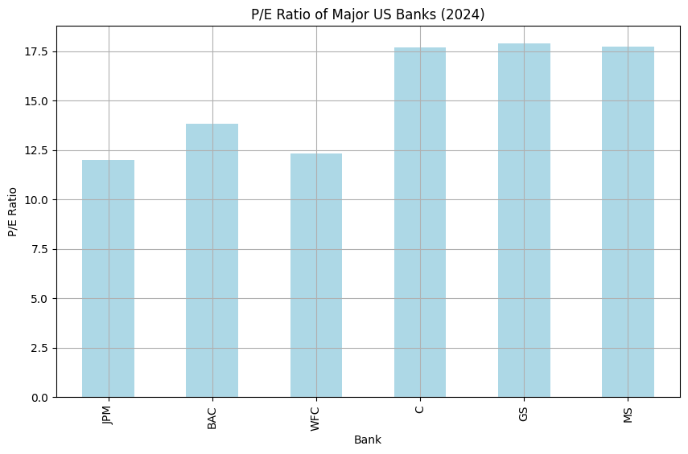**Inference:**

* **Valuation Metric:** The P/E ratio is a common valuation metric that compares a bank's current share price to its per-share earnings. A higher P/E ratio might indicate that the market expects future growth, while a lower P/E ratio could suggest undervaluation or potential issues.
* **Market Expectations:** Banks with higher P/E ratios might be perceived as having better growth prospects, possibly due to strong CRM practices that drive future earnings.
* **Regulatory Considerations:** Regulatory compliance can impact earnings and, consequently, the P/E ratio. Banks facing regulatory challenges might have lower P/E ratios due to reduced earnings expectations.

**Graph 6:** Market Capitalization of Major US Banks (2024):

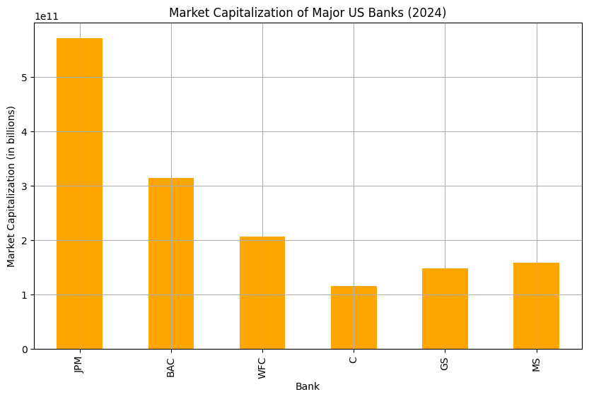**Inference:**

* **Size and Scale:** Market capitalization represents the total market value of a bank's outstanding shares. Larger market caps indicate bigger, more established banks.
* **Investor Confidence:** Higher market capitalization can reflect greater investor confidence, which can be influenced by effective compliance and CRM practices.
* **Comparative Analysis:** Comparing market caps helps identify the relative size and market position of each bank, providing insights into their competitive standing.

**Graph 7:** Return on Equity (ROE) of Major US Banks (2024):

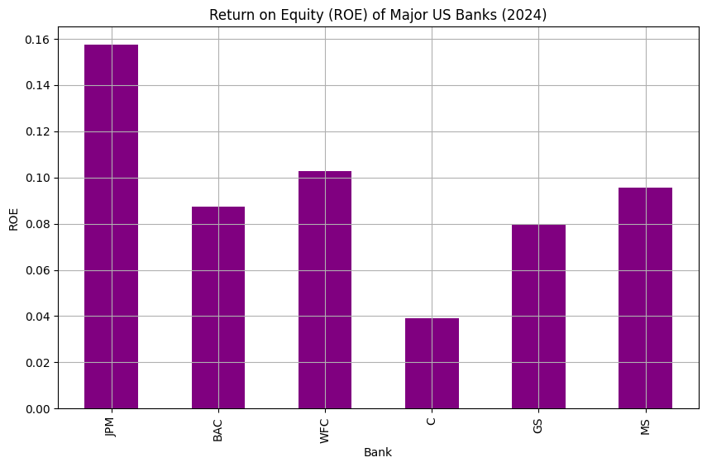**Inference:**

* **Profitability Measure:** ROE measures how effectively a bank is using its equity to generate profits. Higher ROE indicates better financial performance and efficient use of equity.
* **CRM Impact:** Effective CRM practices can enhance profitability by improving customer retention and satisfaction, leading to higher ROE.
* **Regulatory Influence:** Compliance with regulatory requirements can impact profitability. Banks that manage to comply efficiently without incurring excessive costs might exhibit higher ROE.

**Graph 8:** Net Interest Margin (NIM) of Major US Banks (2024):

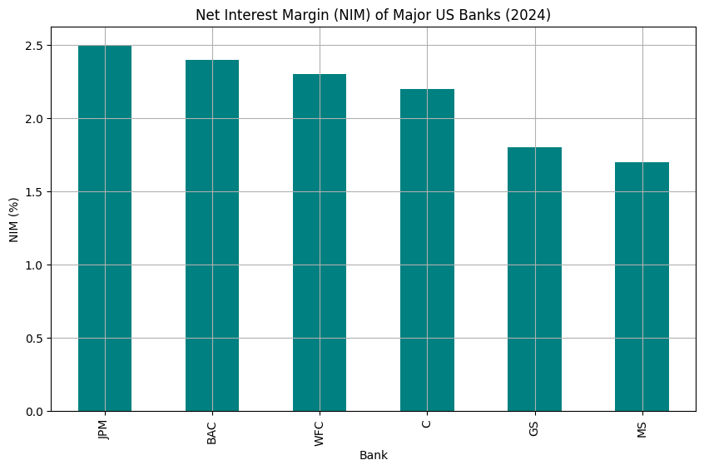**Inference:**

* **Interest Income Efficiency:** NIM measures the difference between the interest income generated and the interest paid out. Higher NIM indicates better efficiency in generating interest income.
* **Regulatory Impact:** Regulatory policies can influence NIM by affecting interest rates and lending practices. Banks that navigate regulatory environments effectively might maintain higher NIM.
* **CRM Influence:** Strong CRM practices can lead to better customer relationships, potentially resulting in more favourable lending terms and higher NIM.

**Conclusion:**

In the dynamic and highly regulated banking sector, the integration of robust compliance and regulatory frameworks with effective customer relationship management (CRM) strategies is paramount for sustainable success. Compliance and regulatory affairs ensure that banks operate within legal boundaries, maintain financial stability, and protect consumer interests, thereby fostering trust and integrity in the financial system. Concurrently, CRM practices enable banks to understand and meet customer needs, enhance satisfaction, and build loyalty, driving growth and competitive advantage. Together, these elements create a balanced approach where regulatory adherence supports a stable operational environment, while CRM initiatives cultivate strong, lasting customer relationships, ultimately contributing to the overall resilience and profitability of banks.